Overweight and Obesity in Mothers and Risk of Preterm Birth and Low Birth Weight Infants: Systematic Review and Meta-Analyses (McDonald, Han, Mulla, and Beyene. BMJ 2010;341:c3428).
Source: Figure 2. Forest plot of risk of preterm birth before 37 weeks in overweight and obese women compared with women of normal weight in cohort studies (page 7)
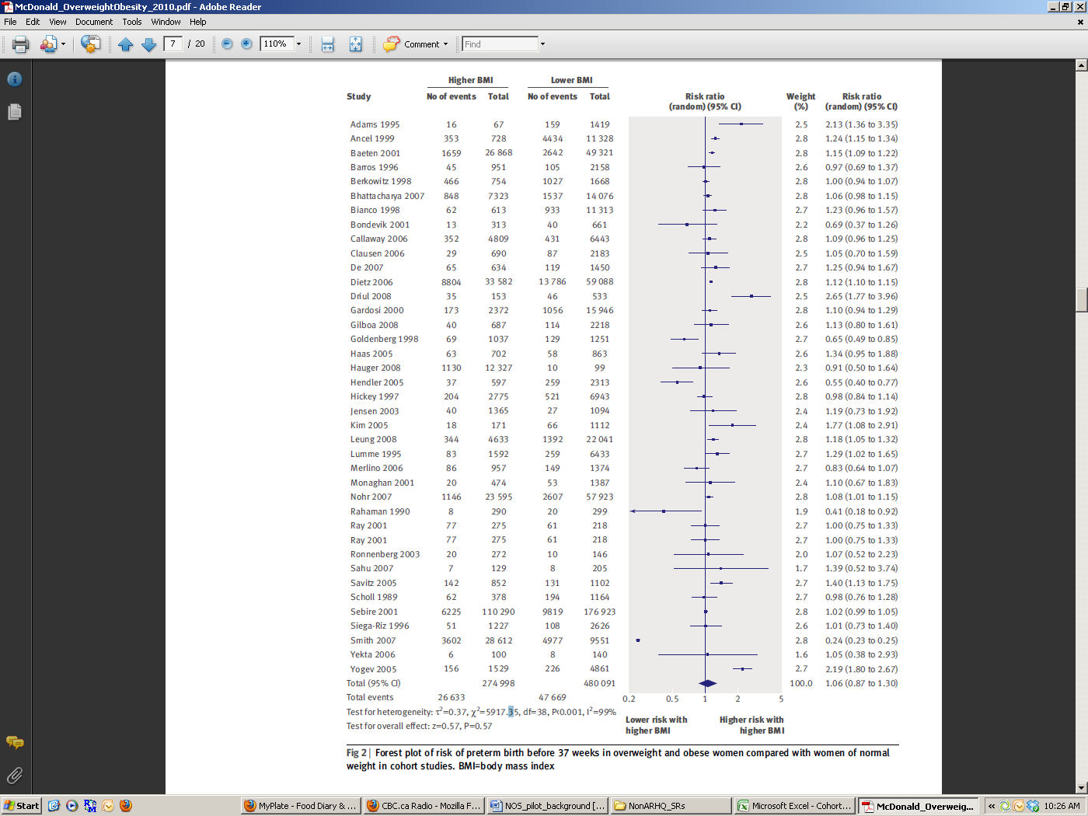
Objectives/Aims: To determine the relation between overweight and obesity in mothers and preterm birth and low birth weight in singleton pregnancies in developed and developing countries.
Primary outcome:
-preterm birth (<37 weeks gestation)
Participants:
-pregnant women with singleton pregnancies only

Comparability:
-age
-race, parity, smoking, marital status, education, socio-economic status, co-morbidities (e.g., diabetes, pre-eclampsia, gestatitional diabetes)

Followup:
-Not applicable (outcomes [preterm birth/birth weight] are obtained as soon as birth occurs)

Adequacy of followup:
-≥80% considered adequate

